**DOCKER  
KUBERNETES**

**STEPHEN GRIDER**

**Table of Contents**

[**I] Dive into Docker** 5](#_Toc104643218)

3. Why Use Docker 5

4. What is Docker 5

5. Docker for Mac/Windows 5

6. Installing Docker on MacOS 5

7. Installing Docker with WSL2 on Windows 10 Home and Pro 5

8. Installing Docker for Windows Professional with HyperV 6

9. More Windows Professional with HyperV 6

10. More Windows Professional with HyperV 6

11. Installing Docker on Linux 6

12. Using the Docker Client 6

13. But Really… What’s a Container? 6

14.How’s Docker Running on Your Computer? 6

[**II] Manipulating Containers with Docker Client** 7](#_Toc104643231)

15. Docker Run in Detail 7

16. Overriding Default Commands 7

17. Listing Running Containers 7

18. Container Lifecycle 7

19. Restarting Stopped Containers 7

20. Removing Stopped Containers 7

21. Retrieving Log Outputs 7

22. Stopping Containers 7

23. Multi-Command Containers 7

24. Executing Commands in Running Containers 7

25. The Purpose of IT Flag 7

26. Getting a Command Prompt in a Container 7

27. Starting with a Shell 7

28. Container Isolation 7

[**III] Building Custom Images Through Docker Server** 8](#_Toc104643246)

29. Creating Docker Images 8

30. Buildkit for Docker Desktop 8

31. Building a DockerFile 8

32. Dockerfile Teardown 8

33. What’s a Base Image? 8

34. The Build Process in Detail 8

35. A Brief Recap 8

36. Rebuilds with Cache 8

37. Tagging an Image 8

38. Quick Note for Windows Users 8

39. Manual Image Generation with Docker Commit 8

[**IV] Making Real Projects with Docker** 9](#_Toc104643258)

40. Project Outline 9

41. Node Server Setup 9

42. A Few Planned Errors 9

43. A required Node Base Image Version 9

44. Base Image Issues 9

45. A Few Missing Files 9

46. Copying Build Files 9

47. Container Port Mapping 9

48. Specifying a Working Directory 9

49. Unnecessary Rebuilds 9

50. Minimizing Cache Busting and Rebuilds 9

[**IV] Making Real Projects with Docker** 10](#_Toc104643270)

40. Project Outline 10

41. Node Server Setup 10

42. A Few Planned Errors 10

43. A required Node Base Image Version 10

44. Base Image Issues 10

45. A Few Missing Files 10

46. Copying Build Files 10

47. Container Port Mapping 10

48. Specifying a Working Directory 10

49. Unnecessary Rebuilds 10

50. Minimizing Cache Busting and Rebuilds 10

[**V] Docker Compose with Multiple Local Containers** 11](#_Toc104643282)

51. App Overview 11

52. App Server Starter Code 11

53. Assembling a Dockerfile 11

54. Introducing Docker Compose 11

55. Docker Compose Files 11

56. Networking with Docker Compose 11

57. Docker Compose Commands 11

58. Stopped Docker Compose Containers 11

59. Container Maintenance with Docker Compose 11

60. Automatic Container Restarts 11

61. Container Status with Docker Compose 11

# **I] Dive into Docker**

## 3. Why Use Docker

## 

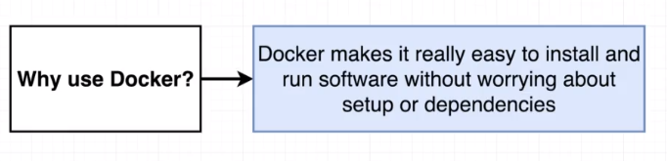

## 4. What is Docker

## 

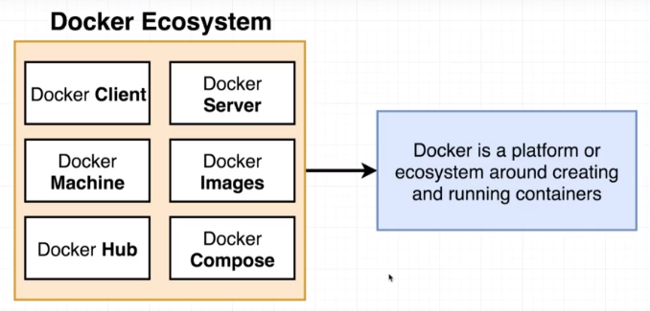

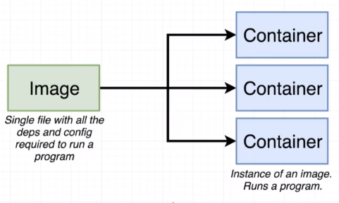

## 5. Docker for Mac/Windows

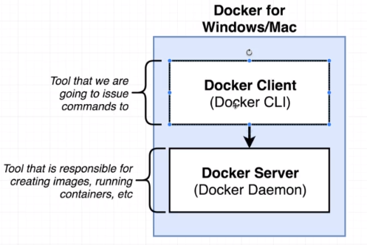

## 6. Installing Docker on MacOS

## 7. Installing Docker with WSL2 on Windows 10 Home and Pro

## Installing Docker for Windows Professional with HyperV

## 8. Installing Docker on Linux

## 9. Using the Docker Client

docker version

docker run hello-world

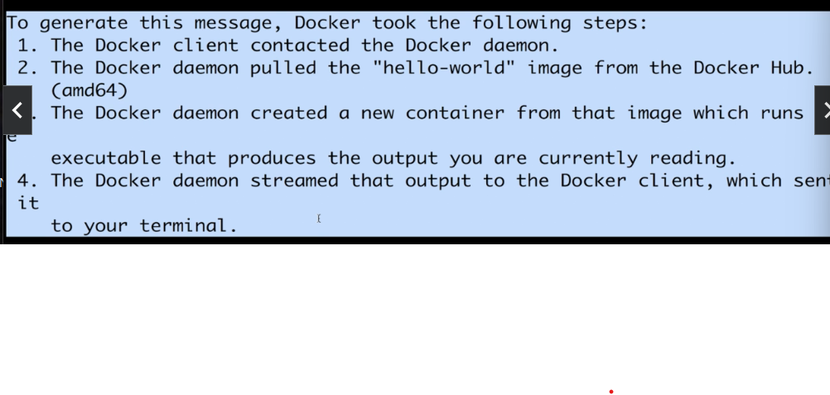

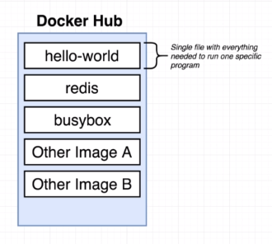

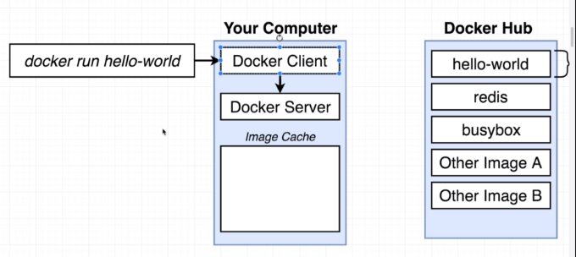

## 10. But Really… What’s a Container?

How OS works?

## 

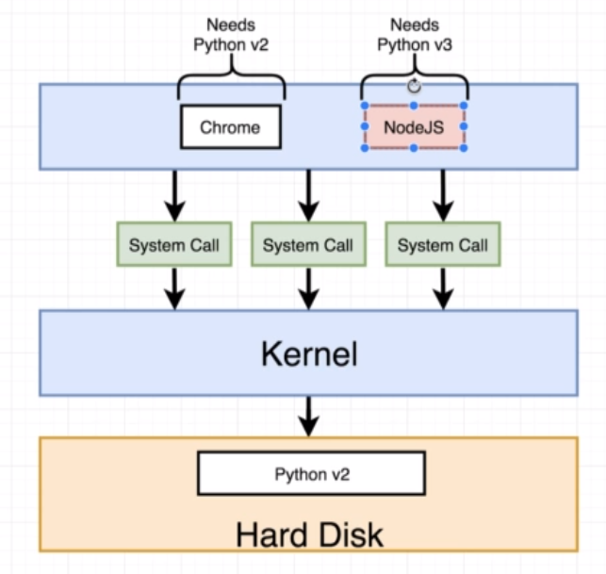

Solution:

1. Namespacing in OS

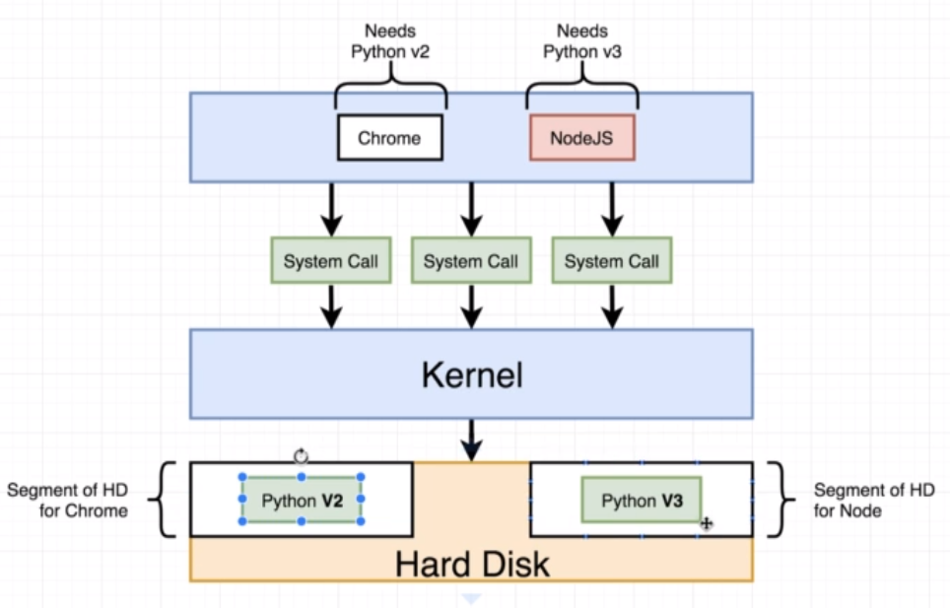

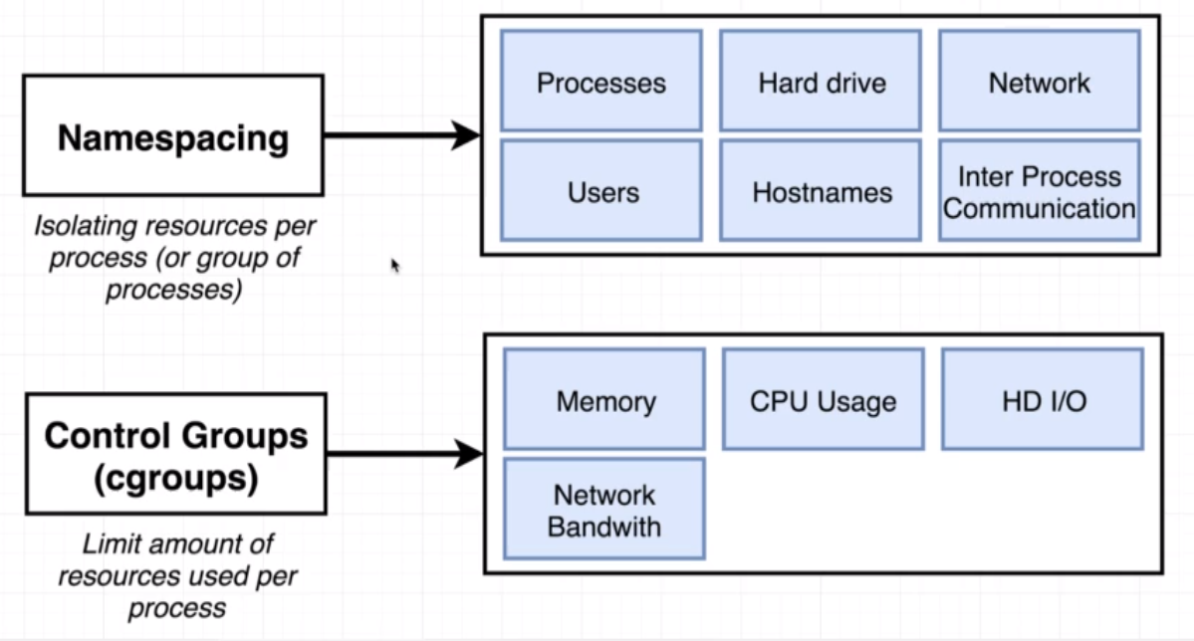

1. Control groups
2. Containers

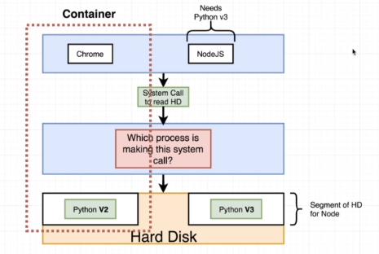

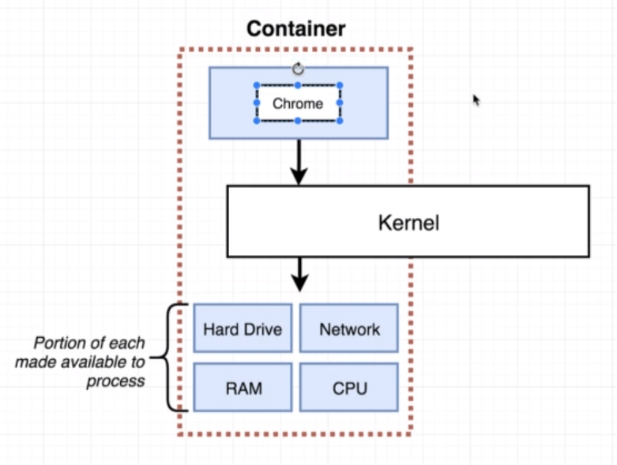

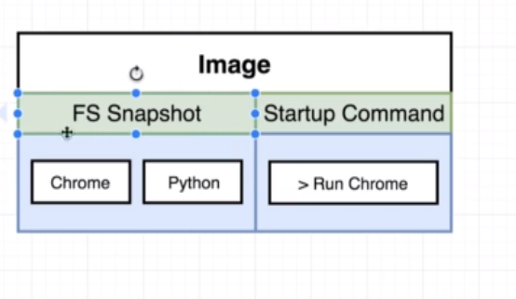

## 11.How’s Docker Running on Your Computer?

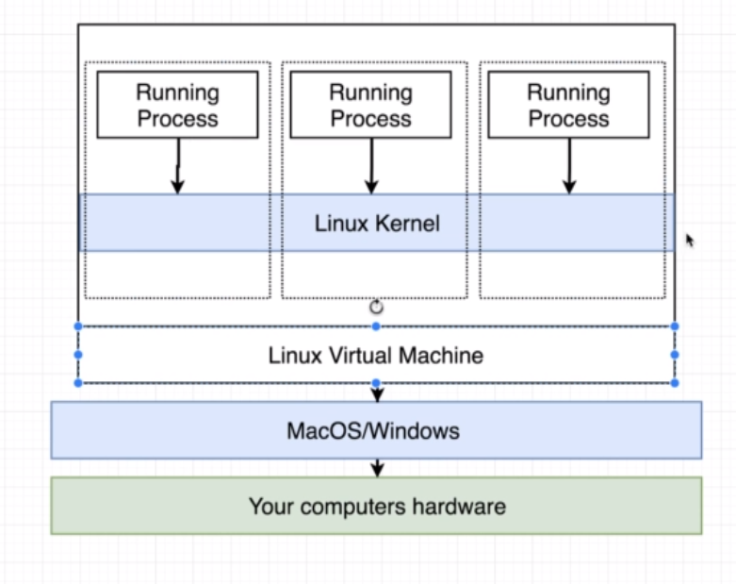

# **II] Manipulating Containers with Docker Client**

## 12. Docker Run in Detail

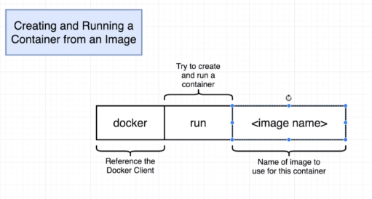

## 13. Overriding Default Commands

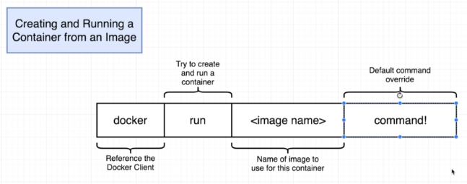

Docker run busybox ls

O/p: etc

Root

Etc

Var & so on

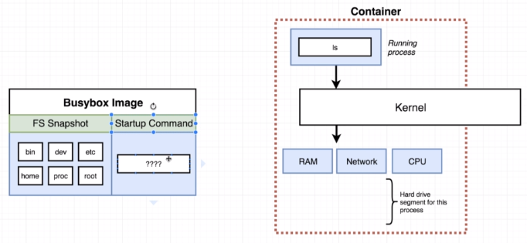

## 14. Listing Running Containers

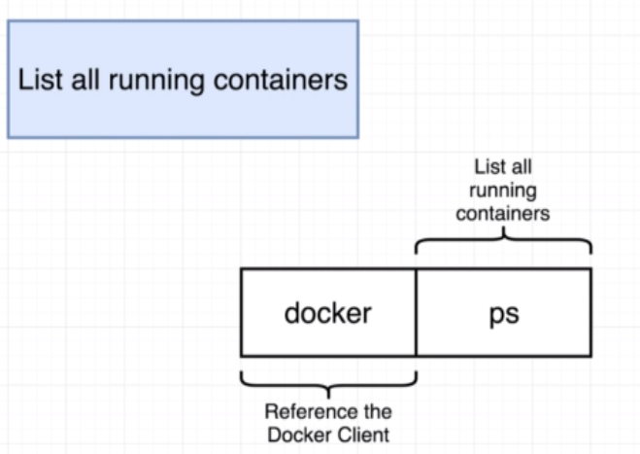

Docker run busybox ping google.com

Docker ps



## 15. Container Lifecycle

Docker ps –all

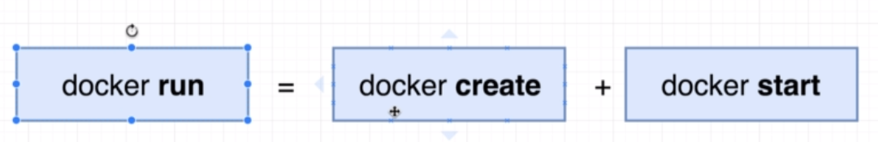

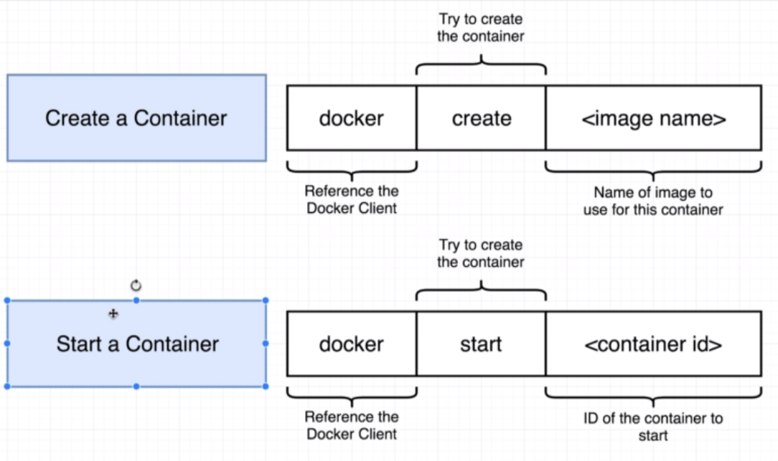

Docker start -a hello-world 🡺 will show output on container

Docker start hello-world

## 16. Restarting Stopped Containers

## 17. Removing Stopped Containers

Docker system prune 🡺

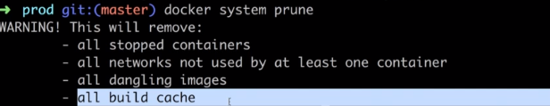

## 18. Retrieving Log Outputs

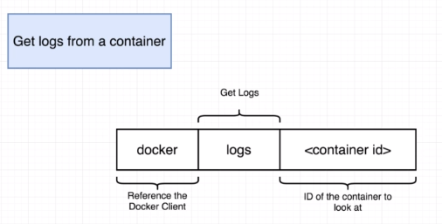

## 19. Stopping Containers

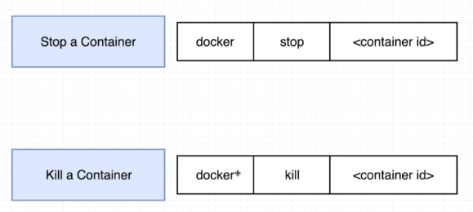

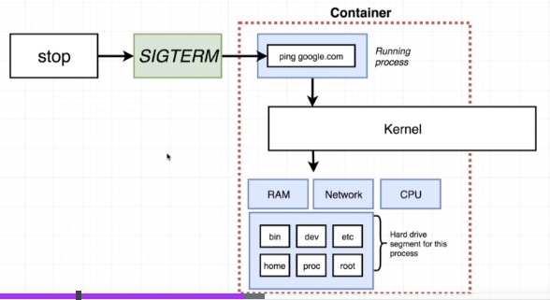

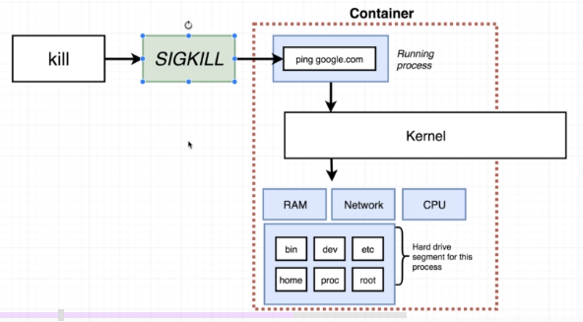

Kill instantly stops

## 20. Multi-Command Containers

## 21. Executing Commands in Running Containers

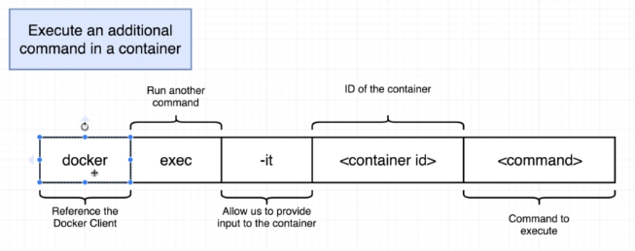

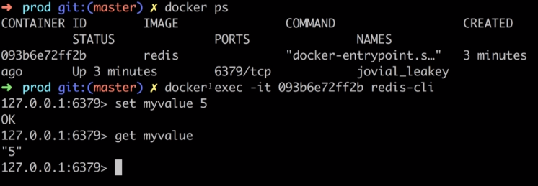

## 22. The Purpose of IT Flag

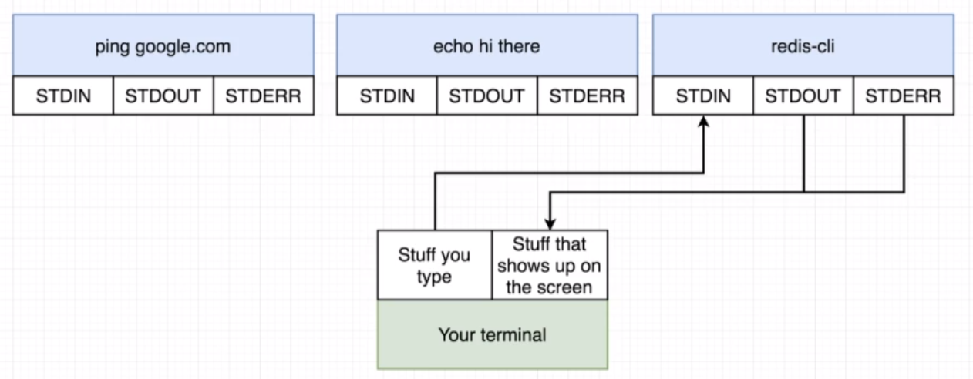

## 26. Getting a Command Prompt in a Container

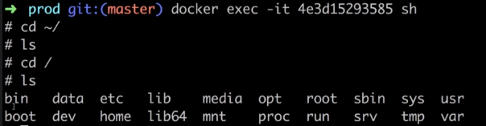

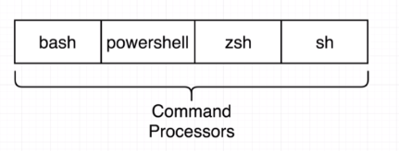

## 27. Starting with a Shell

## 28. Container Isolation

# **III] Building Custom Images Through Docker Server**

## 29. Creating Docker Images

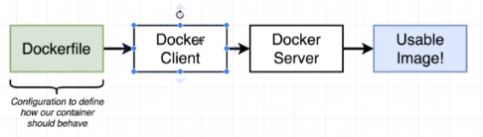

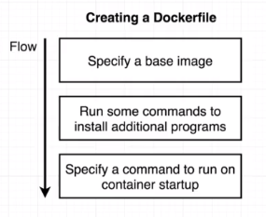

## 30. Buildkit for Docker Desktop

## 31. Building a DockerFile

## Mkdir redis-image

Cd redis-image

Use vs-code

Open above dir

**Dockerfile**

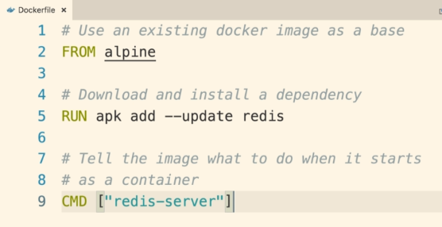

Docker build . 🡺 ashdsagdhe73837

Docker run ashdsagdhe73837

## 32. Dockerfile Teardown

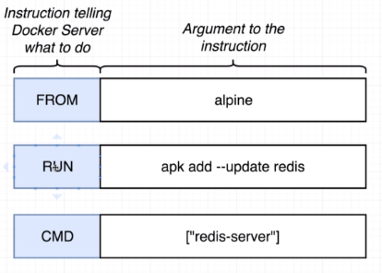

## 33. What’s a Base Image?

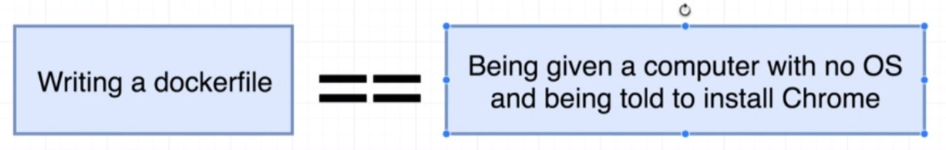

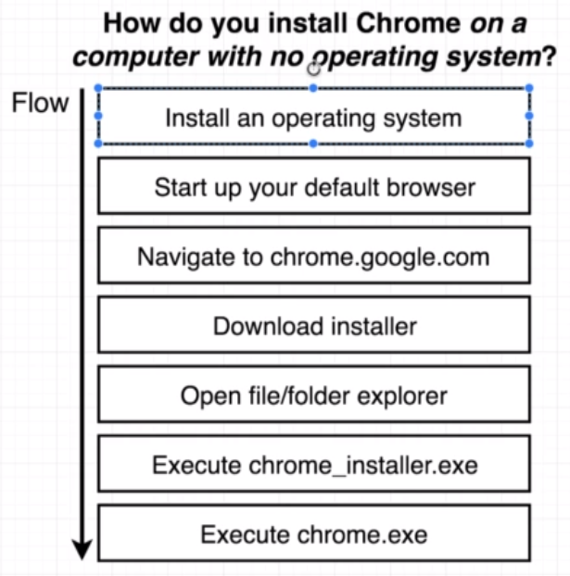

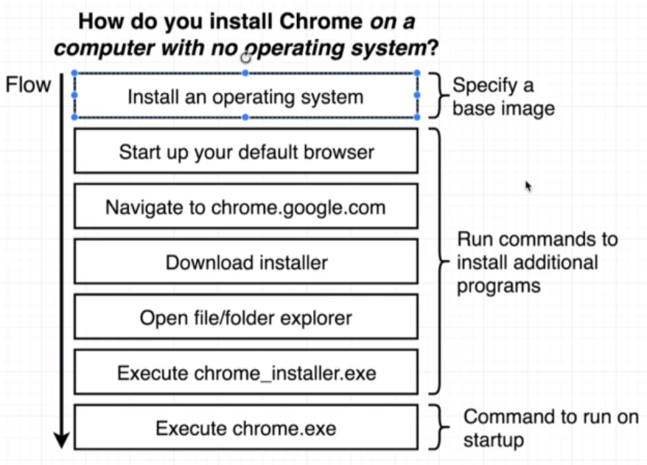

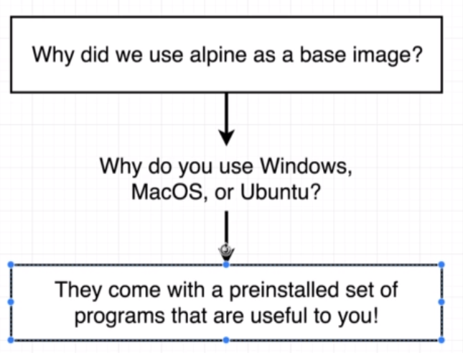

## 34. The Build Process in Detail

## 35. A Brief Recap

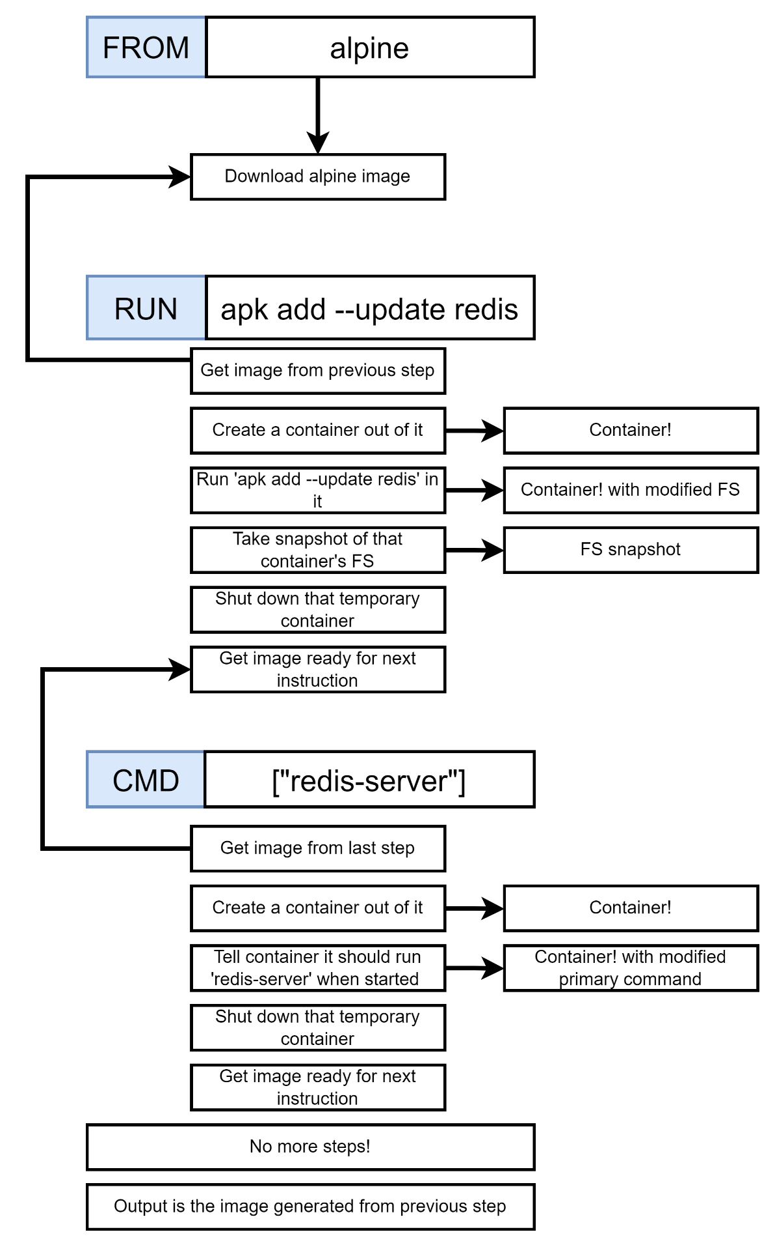

## 36. Rebuilds with Cache

## 37. Tagging an Image

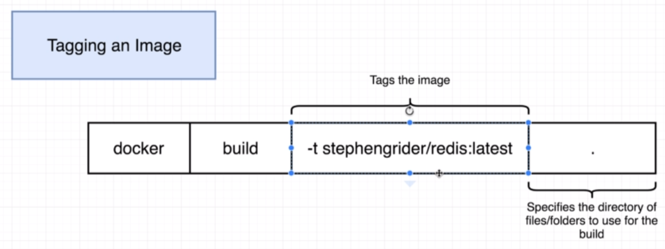

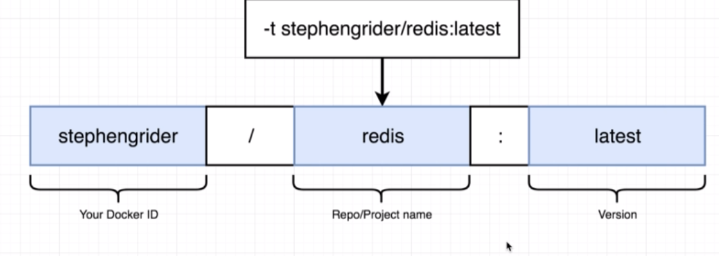

## 38. Quick Note for Windows Users

## 39. Manual Image Generation with Docker Commit

# **IV] Making Real Projects with Docker**

## 40. Project Outline

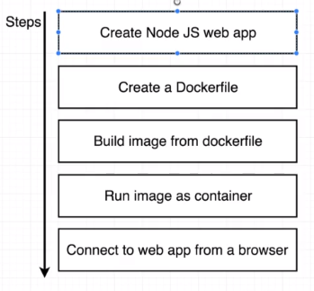

## 41. Node Server Setup

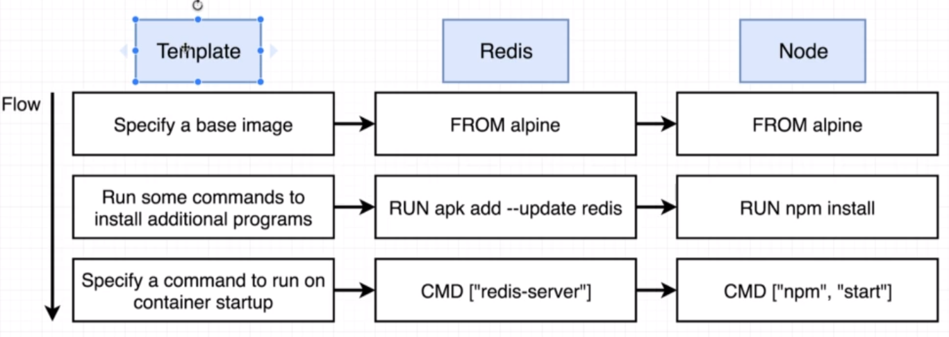

## 42. A Few Planned Errors

n the upcoming lecture, we will be adding a Node base image to our Dockerfile. To properly follow along with the lectures, please add this specific version:

Change this:

FROM node:alpine

to this:

FROM node:14-alpine

If you do not specify a Node version

If you do not specify a version, you will meet a number of errors caused by changes in the newest versions of Node:

npm ERR! idealTree already exists

This can be resolved by adding a WORKDIR right after the FROM instruction: (we will be adding this in the Specifying a Working Directory lecture anyway):

FROM node:alpine

WORKDIR /usr/app

## 43. A required Node Base Image Version

## 44. Base Image Issues

## 45. A Few Missing Files

## 46. Copying Build Files

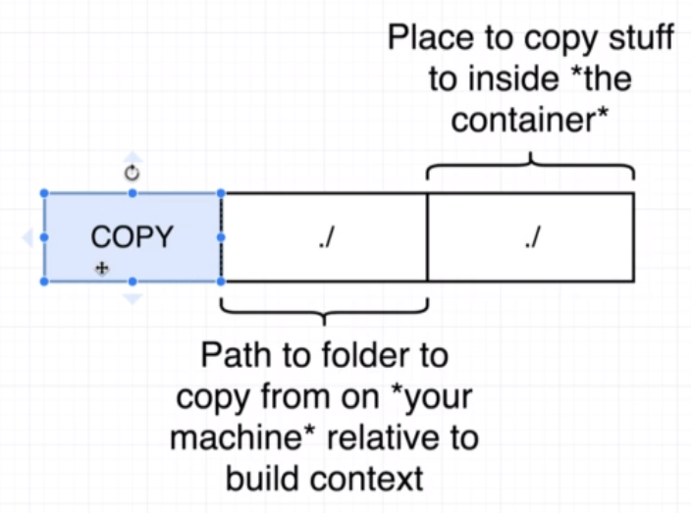

## 47. Container Port Mapping

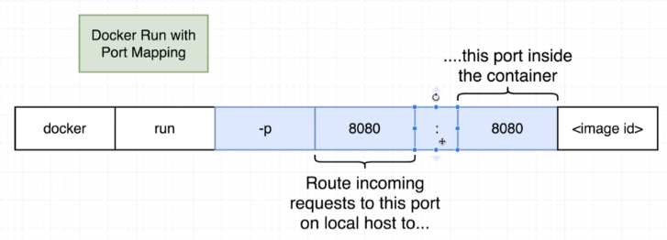

## 48. Specifying a Working Directory

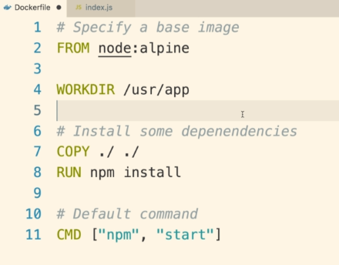

## 49. Unnecessary Rebuilds

## 50. Minimizing Cache Busting and Rebuilds

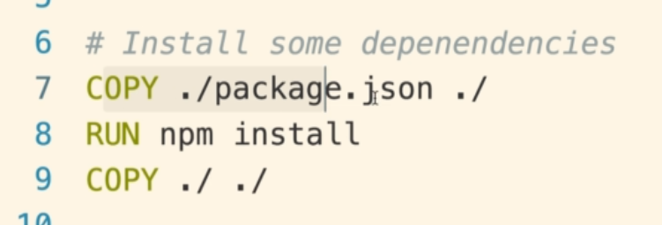

# **V] Docker Compose with Multiple Local Containers**

## 51. App Overview

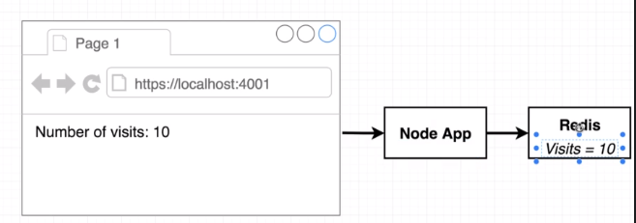

## 52. App Server Starter Code

## 53. Assembling a Dockerfile

## 54. Introducing Docker Compose

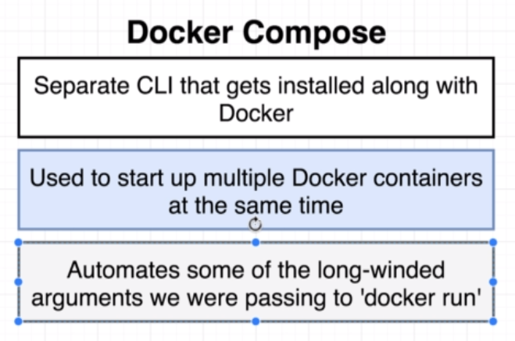

## 55. Docker Compose Files

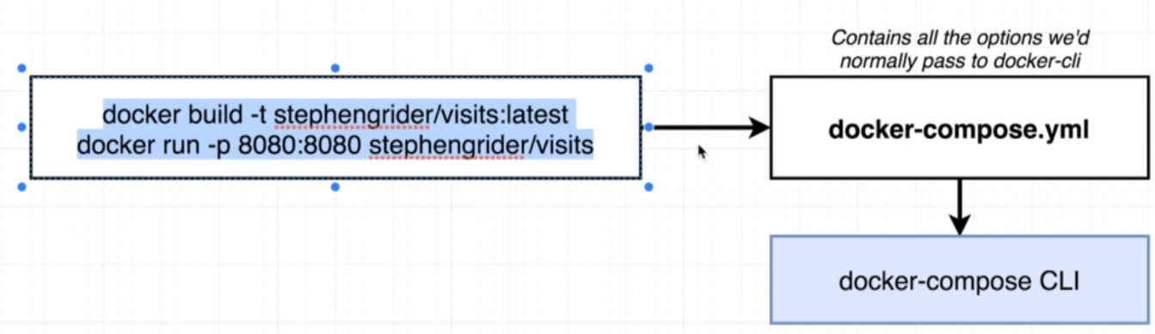

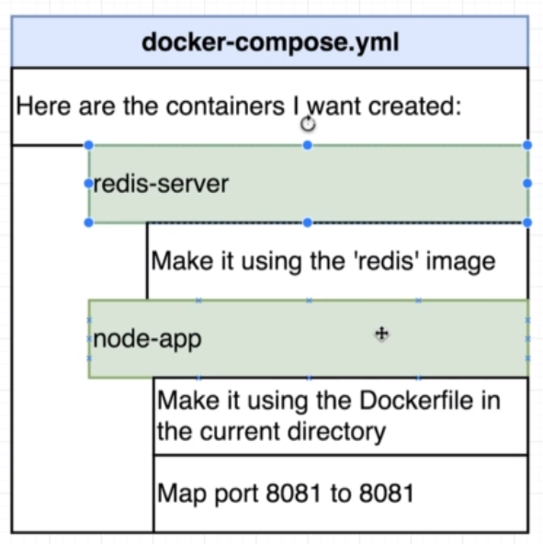

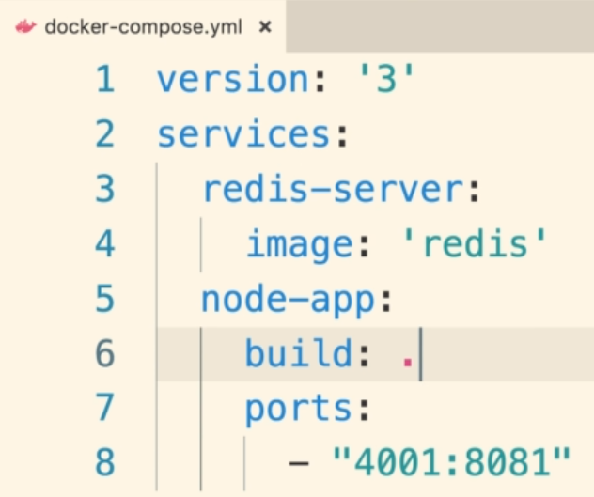

## 56. Networking with Docker Compose

## 57. Docker Compose Commands

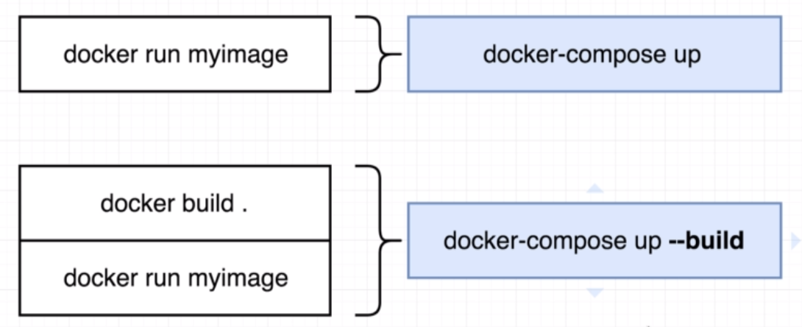

Docker-compose.yml in pwd

Docker-compose up

## 58. Stopped Docker Compose Containers

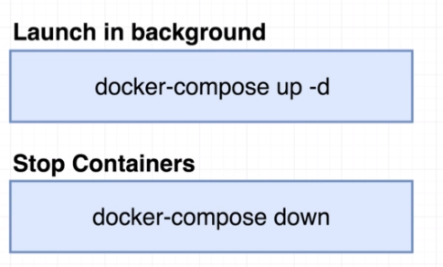

## 59. Container Maintenance with Docker Compose

## 60. Automatic Container Restarts

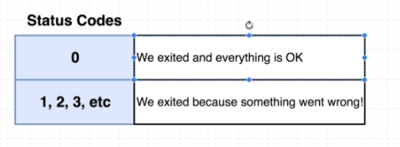

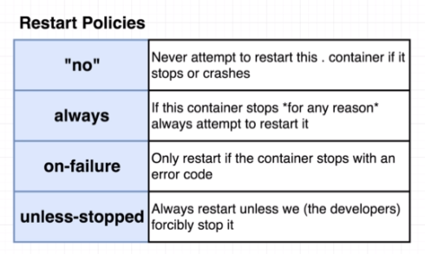

## 61. Container Status with Docker Compose

# **VI] Creating A Production-Grade Workflow**

## 62. Development Workflow

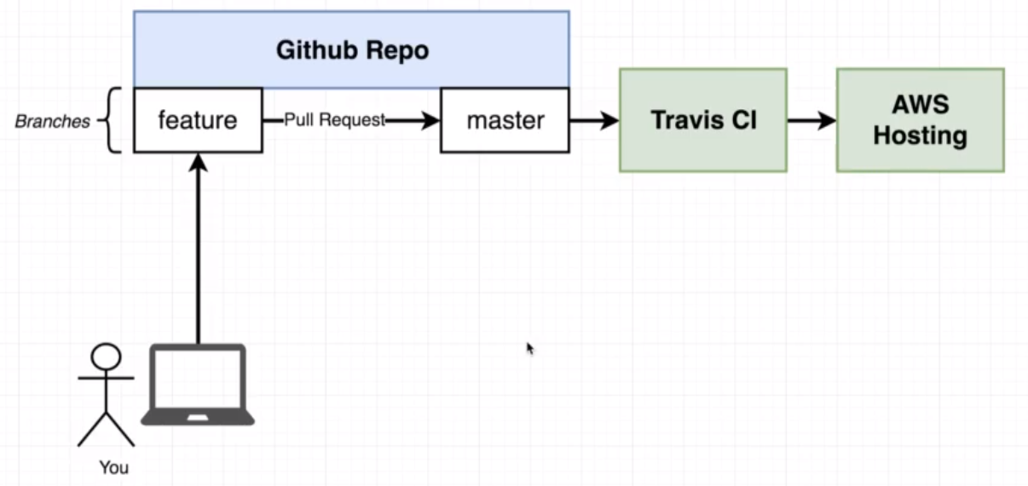

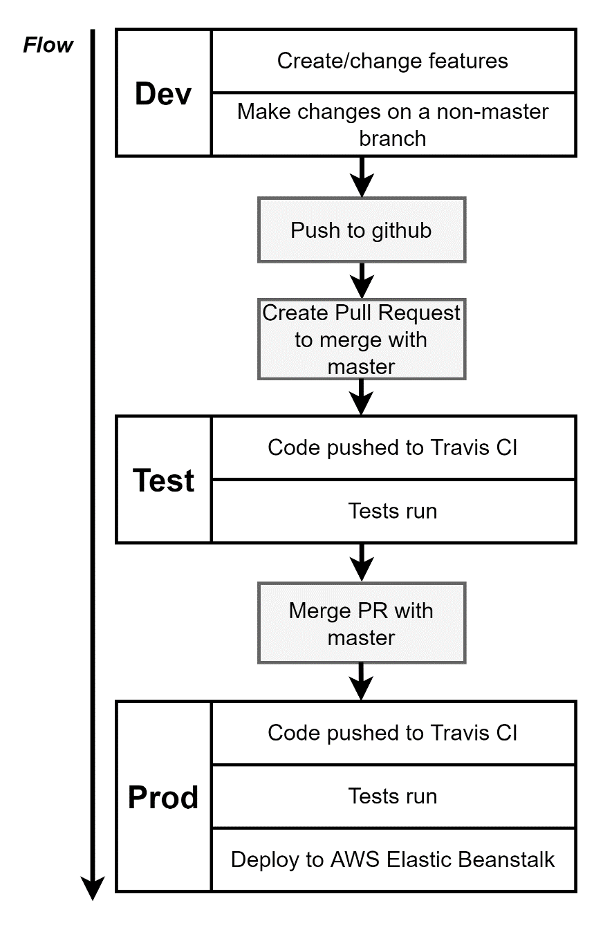

## 63. Flow Specifics

## 64. Docker’s Purpose

## 65. Project Generation

## 66. Create React App Generation

Instead of this:

npm install -g create-react-app

create-react-app frontend

We need to run this command:

npx create-react-app frontend

## 67. More on Project Generation

## 68. Necessary Commands

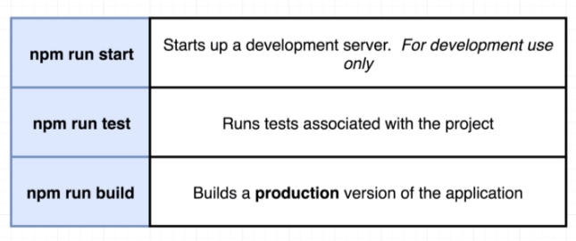

## 69. creating the Dev Dockerfile

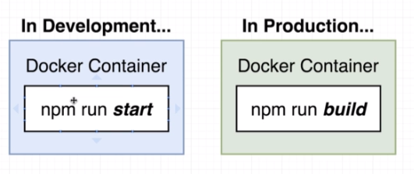

Dockerfile.dev

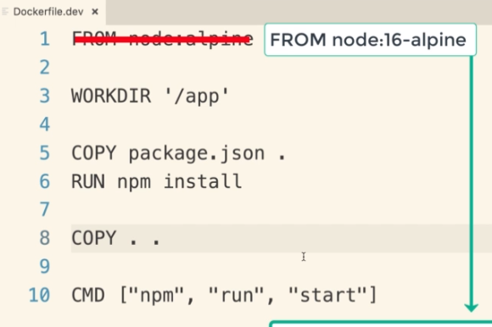

Docker build **-f** Dockerfile.dev

## 70. Duplicating Dependencies

## 71. Starting the Container

## 72. Docker Volumes

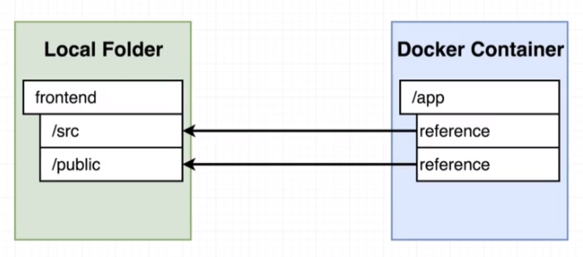

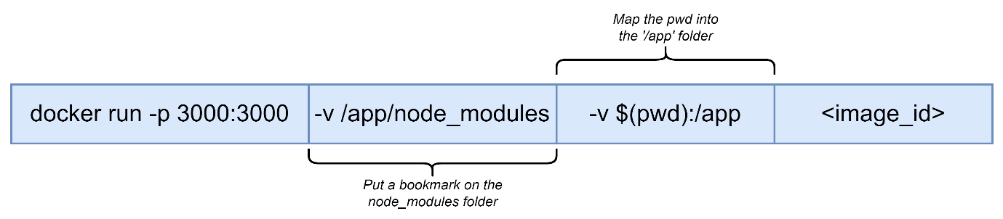

## 73. WSL2 and Windows users note

## 74. Bookmarking Volumes

## 75. Shorthand with Docker Compose

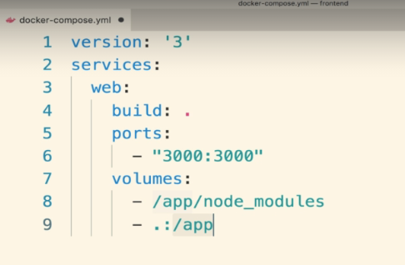

Produce an error since Dockerfile is named as Dockerfile.dev

## 76. Overriding Dockerfile Selection

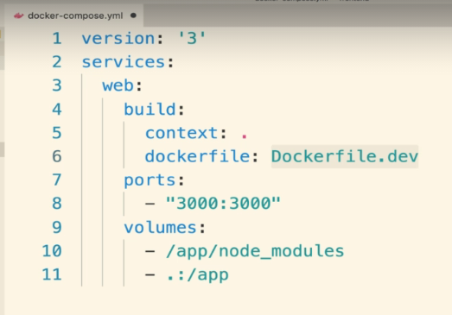

## 77. Do we need Copy?

## 79. Executing Tests

## 80. Docker Compose for Running Tests

## 81. Shortcomings on testing

## 82. Need for Nginx

## 83. Multi-step Docker Builds

## 84. Implementing Multi-Step Builds

## 85. Running Nginx

# **VII] Continuous Integration and Deployment with AWS**

## 86. Services Overview

## 87. Github Setup

## 88. Imp Info about Travis and Account Registration

## 89. Travis CI Setup

## 90. Travis YML File Config

## 91. Required Travis Script updates

## 92. A Touch More Travis Setup

## 93. Automatic build Creation

## 94. Required Updates for Amazon Linux 2 Platform

## 95. AWS Elastic Beanstalk

## 96. More On Elastic Beanstalk

## 97. Travis Config for Deployment

## 98. Travis Keys Update

## 99. Automated Deployments

## 100. Exposing Ports Through Dockerfile

## 101. Workflow with Github

## 102. Redeploy on Pull Request Merge

## 103. Deployment Wrap up

## 104. Environment Cleanup

## 105. AWS Config Cheat Sheet

## 106. Finished Project with Updates Applied

# **VIII] Building a Multi-Container Application**

## 107. Single Container Deployment Issues

## 108. Application Overview

## 109. A Quick Note

## 110. Application Architecture

## 111. Worker Process Setup

## 112. Express API Setup

## 113. Imp Update for Table Query

## 114. Connecting to Postgres

## 115. More Express API Setup

## 116. Create React App Generation

## 117. Generating React App

## 118. Fetching Data in The React app

## 119. Rendering Logic in the App

## 120. Exporting the Fib Class

## 121. Routing in the React App

# **IX] “Dockerizing” Multiple Services**

## 122. Checkpoint Files

## 123. Checkpoint Catchup

## 124. Dockerizing a React App

## 125. DockerizingGeneric Node Apps

## 126. Adding Postgres as a Service

## 127. Docker-Compose Config

## 128. Postgres Database Required Fixes and Updates

## 129. Environment Variables with Docker Compose

## 130. Required Worker Environment Variables

## 131. The Worker and Client Services

## 132. Nginx Path Routing

## 133. Routing with Nginx

## 134. Building a Custom Nginx Image

## 135. Starting up Docker Compose

## 136. Nginx connect() failed – Connection refused while connecting to upstream

## 137. Troubleshooting Startup Bugs

## 138. Websocket Connection to ‘ws://localhost:3000/ws’ failed

## 139. Opening Websocket Connections

# **X] A Continuous Integration Workflow for Multiple Images**

## 140.

## 141.

## 142.

## 143.

## 144.

## 145.

## 146.

## 147.

## 148.

## 149.

## 150.

# **XI] Multi-Container Deployments to AWS**

## 151.

## 152.

## 153.

## 154.

## 155.

## 156.

## 157.

## 158.

## 159.

## 160.

## 161.

## 162.

## 163.

## 164.

## 165.

## 166.

## 167.

## 168.

## 169.

## 170.

## 171.

## 172.

## 173.

## 174.

## 175.

## 176.

# **XII] Onwards to Kubernetes**

## 177. The Why’s and What’s of Kubernetes

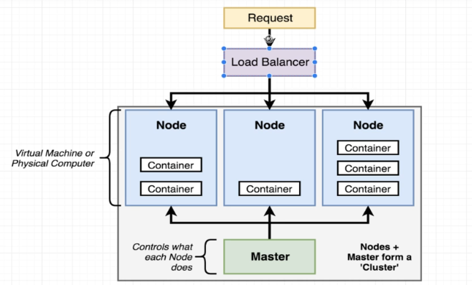

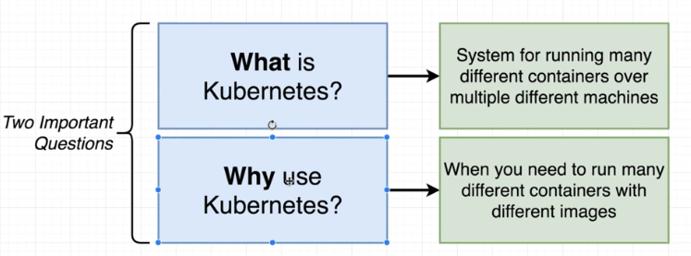

## 178. Kubernetes in Development and Production

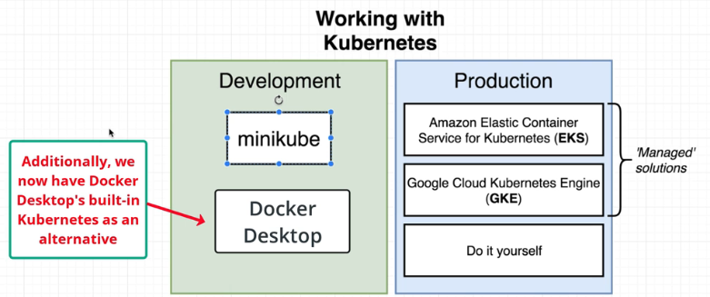

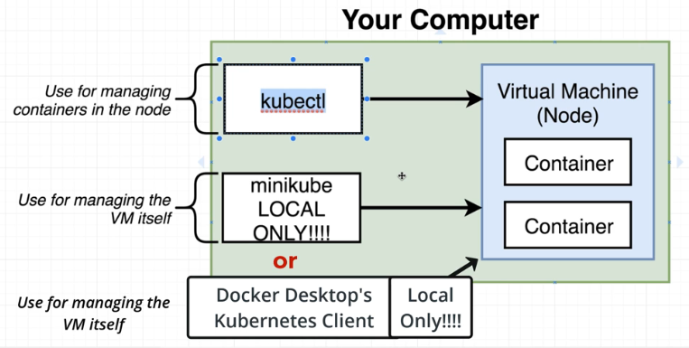

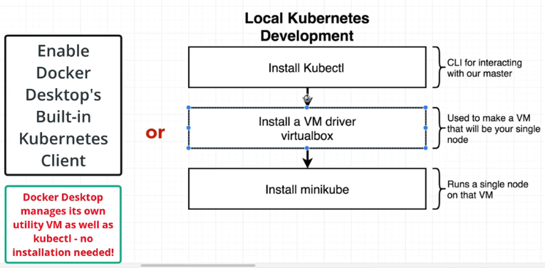

## 179. Docker Desktop’s Kubernetes Setup and Production - MacOS

## 180. Docker Desktop’s Kubernetes Setup and Production – Windows

## 181. Updated Minikube Install and Setup Info - MacOS

## 182. Minikube Setup - MacOS

## 183. Minikube Setup – Windows

## 184. Minikube Setup - Linux

## 185. Mapping Existing Knowledge

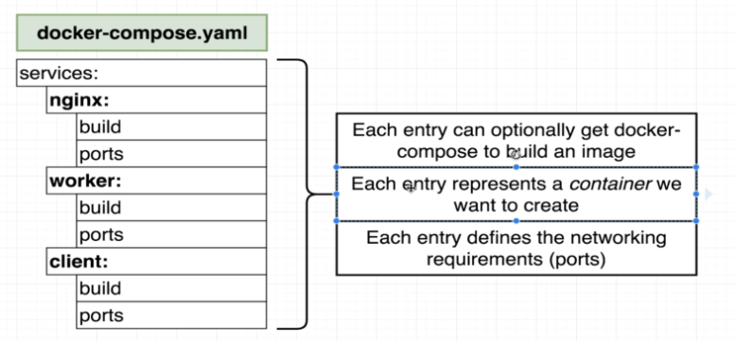

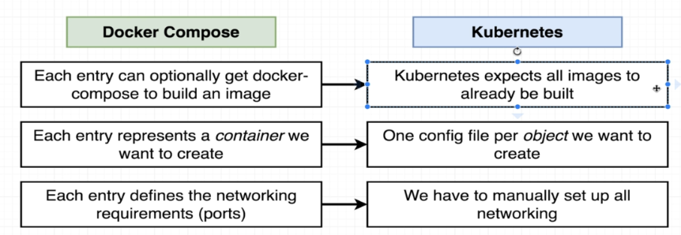

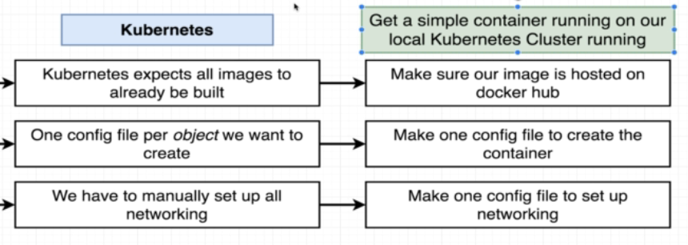

## 186. Quick Note to prevent error

## 187. Adding Config Files

## 188. Object Types and API versions

## 189. Running Container in Pods

## 190. Service Config Files in Depth

## 191. Connecting to Running Containers

## 192. The Entire Deployment Flow

## 193. Imperative vs Declarative Deployments

# **XIII] Maintaining Sets of Containers with Deployments**

## 194.

## 195.

## 196.

## 197.

## 198.

## 199.

## 200.

## 201.

## 202.

## 203.

## 204.

## 205.

## 206.

## 207.

## 208.

## 209.

## 210.

## 211.

# **XIV] A Multi-Container App with Kubernetes**

## 212.

## 213.

## 214.

## 215.

## 216.

## 217.

## 218.

## 219.

## 220.

## 221.

## 222.

## 223.

## 224.

## 225.

## 226.

## 227.

## 228.

## 229.

## 230.

## 231.

## 232.

## 233.

## 234.

## 235.

## 236.

## 237.

## 238.

## 239.

## 240.

## 241.

# **XV] Handling Traffic with Ingress Controllers**

## 242.

## 243.

## 244.

## 245.

## 246.

## 247.

## 248.

## 249.

## 250.

## 251.

## 252.

## 253.

## 254.

## 255.

# **XVI] Kubernetes Production Deployment**

## 256.

## 257.

## 258.

## 259.

## 260.

## 261.

## 262.

## 263.

## 264.

## 265.

## 266.

## 267.

## 268.

## 269.

## 270.

## 271.

## 272.

## 273.

## 274.

## 275.

## 276.

## 277.

## 278.

## 279.

## 280.

## 281.

## 282.

## 283.

## 284.

## 285.

## 286.

## 287.

## 288.

## 289.

## 290.

## 291.

## 292.

## 293.

## 294.

## 295.

## 296.

## 297.

## 298.

# **XIV] HTTPS Setup with Kubernetes**

## 299.

## 300.

## 301.

## 302.

## 303.

## 304.

## 305.

## 306.

## 307.

## 308.

## 309.

## 310.

## 311.

## 312.

## 313.

## 314.

## 315.

## 316.

# **XVIII] Local Development with Skaffold**

## 317.

## 318.

## 319.

## 320.

## 321.

## 322.

## 323.

# **XIX] Extras**

## 324.